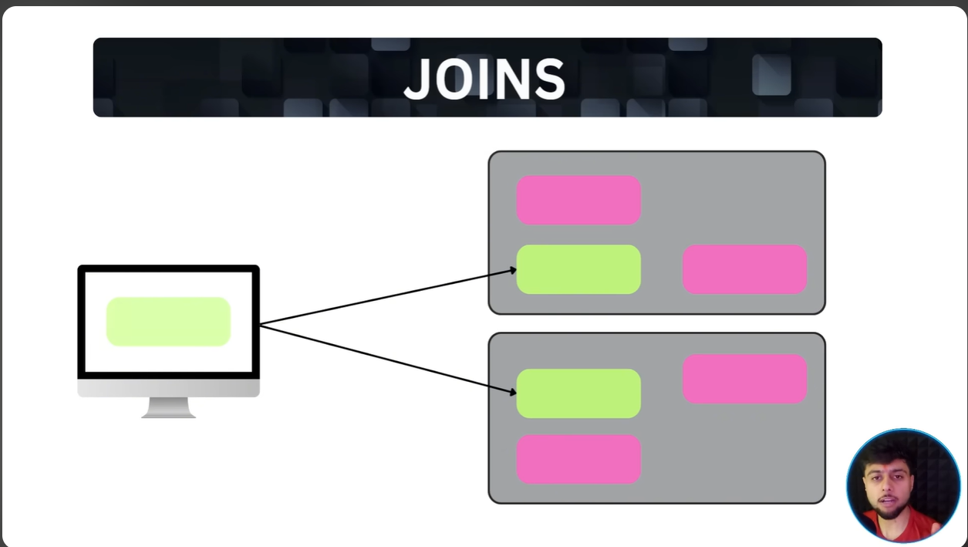
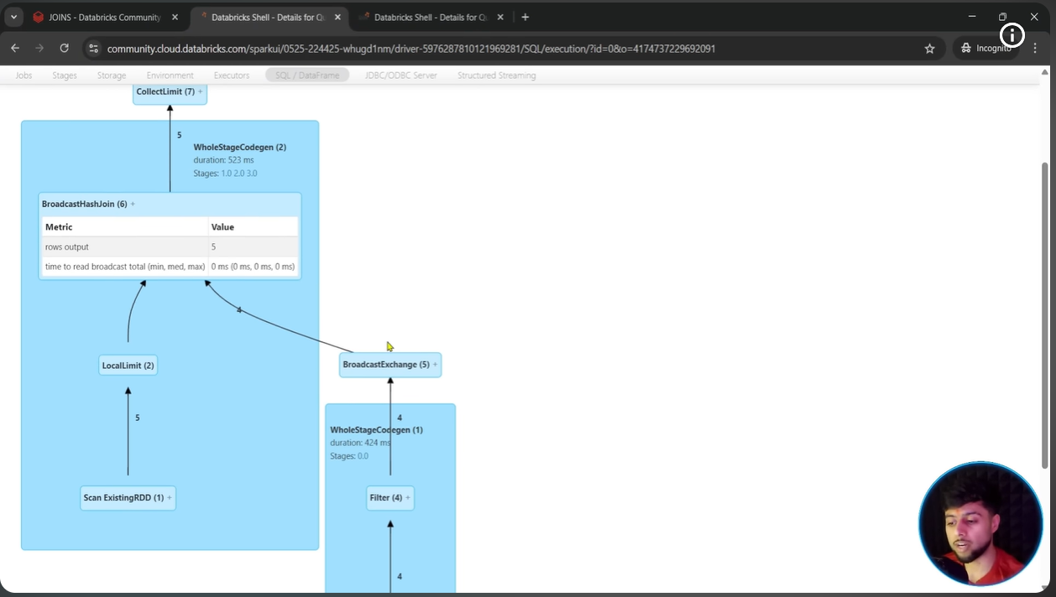
Summary Cheat Sheet
Join Strategy | Real-World Analogy | When Spark Uses It
Broadcast Hash | Handing out tiny cheat-sheets to every table | One dataset is tiny (< 10 MB)
Shuffle Hash | Moving to sections, building a quick lookup list | One dataset is medium-sized
Sort-Merge | Moving to sections, lining up in order, scanning side-by-side | Both datasets are large (Default)

